W04 Assignment: Code Review



Raul Laredo

WDD331

* Is the styling is de-coupled from the html structure? Try using a few components in a page like [button](http://getbootstrap.com/docs/4.0/components/buttons/), [navbar](http://getbootstrap.com/docs/4.0/components/navbar/), or [progress bar](http://getbootstrap.com/docs/4.0/components/progress/). (If you visit Css settings in codepen you can quickly add Bootstrap as an External CSS resource…see the Quick-add box) Can you use them by just using classes or do they require very specific markup to work?

**Yes it is decoupled, because there will always be some coupling between HTML, CSS, and JavaScript. For better or for worse, these technologies like bootstrap were built to interact with each other.**

* Which if any of the philosophies we discussed this week they might be using (BEM, Atomic, OOCSS, etc)?

**I think that bootstrap is using OOCS, SMACSS, SUITCSS and it is atomic.**

* Are the folders they use well named?

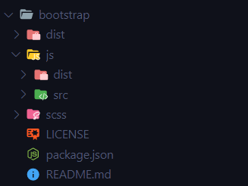

**Yes and with descriptive names wich help to the user to know about the dependencies of the framework.**

* Check out the variables partial. Imagine trying to customize Bootstrap without that settings file! Consider the advantages Sass gives to both the organization and customization of Bootstrap.

**Sass can help to achieve SOLID principles separating every file with different concerns and using it like partials in order to have a product detailed with every component as normally other frameworks are actually working like React, Vue, etc.**

* If you were a developer working on this code and you were asked to work on on something specific...like headline styles...how hard would it be to locate the code and modify it? Would you worry about your changes having unintended consequences after reviewing the class names and architecture of that portion of css?

Bootstrap follows good principles of software engineering like: predictability, reusability, maintainability and scalability and it won’t be difficult to work with.

* Do you like how it is organized? Would you change anything?

**I like the organization, specially the component differentiation in every JavaScript file.**